EXPERIMENT-: 00

BREADBOARD AND MULTIMETER

DIAGRAM:

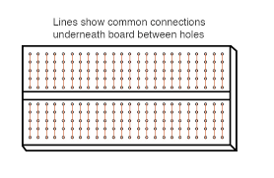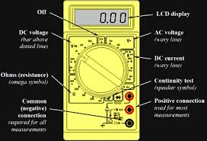

# Theory:-

## Concept used:-

## BREADBOARDS :A breadboard is a solderless device for temporary prototype with electronics and test circuit designs. Most electronic components in electronic circuits can be interconnected by inserting their leads or terminals into the holes and then making connections through wires where appropriate.

**MULTIMETER :** A multimeter or a multitester, also known as a VOM (volt-ohm-milliammeter), is an electronic measuring instrument that combines several measurement functions in one unit. A typical multimeter can measure voltage, current, and resistance. Analog multimeters use a microammeter with a moving pointer to display readings.

## Learning and Observation:-Leanings:

## A multimeter is a device used to measure voltage, current and resistance. Multimeter might be analog type multimeters or digital multimeters, depending on the type of circuit being used. Normally, these hand-held devices are very useful to detect faults or provide field measurements at a high degree of accuracy. They are one of the preferred tools by electricians to troubleshoot electrical problems on motors, appliances, circuit, power supplies, and wiring systems.

# Problems andTroubleshooting:-

# Your digital multimeter should last for a number of years with reasonable care, but there may come a time when you multimeter malfunctions and you’ll have to decide whether to repair it or buy a new one. Before going out and looking for a new multimeter you should use the following techniques to troubleshoot and repair you multimeter.

# The first step is to check the battery. Try to power on your [digital multimeter](https://www.circuitspecialists.com/digital-multimeters). If the multimeter doesn’t turn on or the display is dim you may have a weak or dead battery. Simply replace the battery and you should be good to go.

# If your multimeter powers up but you aren’t getting accurate measurements you may have faulty test leads. Set your multimeter to read resistance and touch the test probe leads together. It should read zero ohms. If you have resistance ratings of over one ohm or the reading is erratic, you should be able to fix the problem by replacing the probe leads.

# If you still haven’t been able to address the issue the next step is to disassemble your digital multimeter. Use a small screwdriver to remove the screws holding the case together.

# After you’ve opened the [multimeter](https://www.circuitspecialists.com/digital-multimeters" \o "multimeter" \t "_blank) locate the fuse and remove it

***LERANING OUTCOMES:***

Just like stethoscope for doctors, stack overflow for programmers, spanners for Mechanic and Jarvis for Tony Stark a **Multimeter** is a very essential instrument for engineers who are interested in working with electronics. Perhaps this would be the first instrument that we get introduced to when starting to explore things related to electronics.